Search Terms：

("opinion mining" OR "sentiment analysis" OR "Aspect-based sentiment analysis" OR "SA" OR "ABSA") AND ("requirements elicitation" OR "requirements discovery" OR "requirements acquisition" OR "requirements specification" OR "requirements gathering" OR "requirements capture") AND ("users' reviews" OR "comments" OR "online reviews" OR "APP reviews" OR "applications" OR "software" OR "app" OR "app store")

Inclusion and exclusion criterion.
No. | Inclusion criterion | No. | Exclusion criterion
I1 | The paper is written in English. | E1 | The paper is an example of gray literature, e.g., a technical report or non-public dissertation.
I2 | The paper was published between January 2013 and February 2023. | E2 | The paper is not from a conference or journal.
I3 | The paper is available in full text. | E3 | The paper is a brief paper, a position paper, or an editorial
I4 | The paper that focuses on using sentiment analysis/opinion mining technology in app reviews or suggestions for requirements elicitation. | E4 | The subject of the paper is a secondary study
- | - | E5 | The paper that does not concentrate on using sentiment analysis/opinion mining technology in app reviews or suggestions for requirements elicitation

RQs
Index | Descriptions
RQ1 | What are the authors/venues/times of these studies?
RQ2 | Which existing datasets are used during the experimental phase?
RQ3 | How can SA techniques support the field of requirement elicitation?
 | RQ3.1 Which types of SA are used?
 | RQ3.2 How do the SA processes affect the results?
 | RQ3.3 Which techniques or tools are used at different stages of the processes?
RQ4 | Which measures are used to evaluate performance in primary studies?
RQ5 | How about the quality of these primary studies?

Inclusion and exclusion criteria:
No. | Inclusion criterion | No. | Exclusion criterion
I1 | The paper is written in English. | E1 | The paper is an example of gray literature, e.g., a technical report or non-public dissertation.
I2 | The paper was published between January 2013 and February 2023. | E2 | The paper is not from a conference or journal.
I3 | The paper is available in full text. | E3 | The paper is a brief paper, a position paper, or an editorial
I4 | The paper that focuses on using sentiment analysis/opinion mining technology in app reviews or suggestions for requirements elicitation. | E4 | The subject of the paper is a secondary study
- | - | E5 | The paper that does not concentrate on using sentiment analysis/opinion mining technology in app reviews or suggestions for requirements elicitation

TECH report & Statistics：
- https://link.springer.com/

("opinion mining" OR "sentiment analysis" OR "Aspect-based sentiment analysis" OR "SA" OR "ABSA") AND ("requirements elicitation" OR "requirements discovery" OR "requirements acquisition" OR "requirements specification" OR "requirements gathering" OR "requirements capture") AND ("users' reviews" OR "comments" OR "online reviews" OR "APP reviews" OR "applications" OR "software" OR "app" OR "app store")
1535

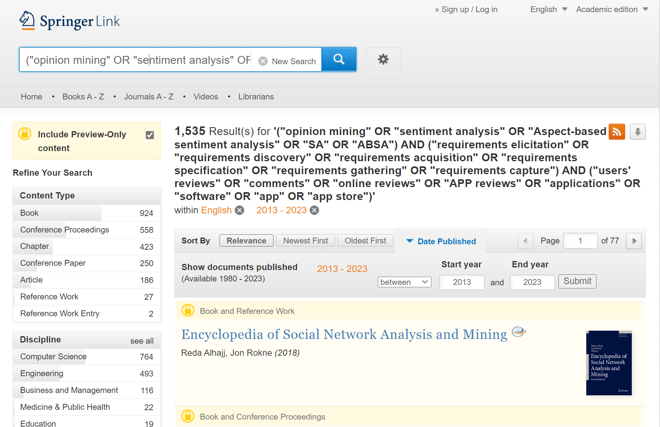

- ACM Digital Library

https://dl.acm.org/

[[All: "opinion mining"] OR [All: "sentiment analysis"]] AND [[All: "requirements elicitation"] OR [All: "requirements discovery"] OR [All: "requirements acquisition"] OR [All: "requirements specification"] OR [All: "requirements gathering"] OR [All: "requirements capture"]] AND [[All: "users' reviews"] OR [All: "comments"] OR [All: "online reviews"] OR [All: "app reviews"] OR [All: "applications"] OR [All: "software"]]
321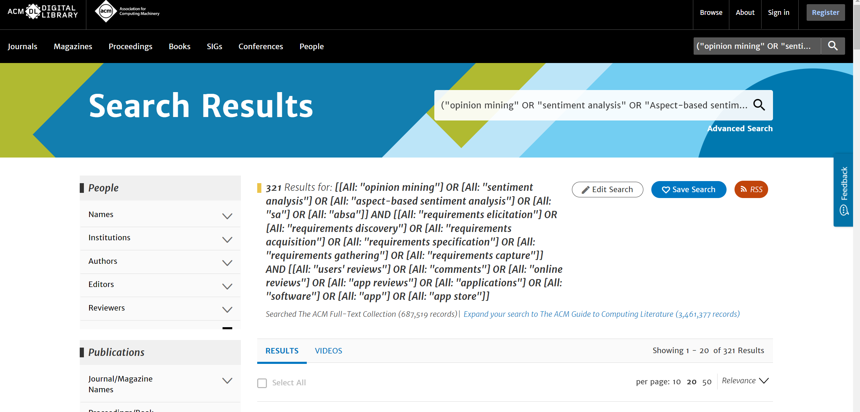
AND [E-Publication Date: (01/01/2013 TO 02/28/2023)]

150
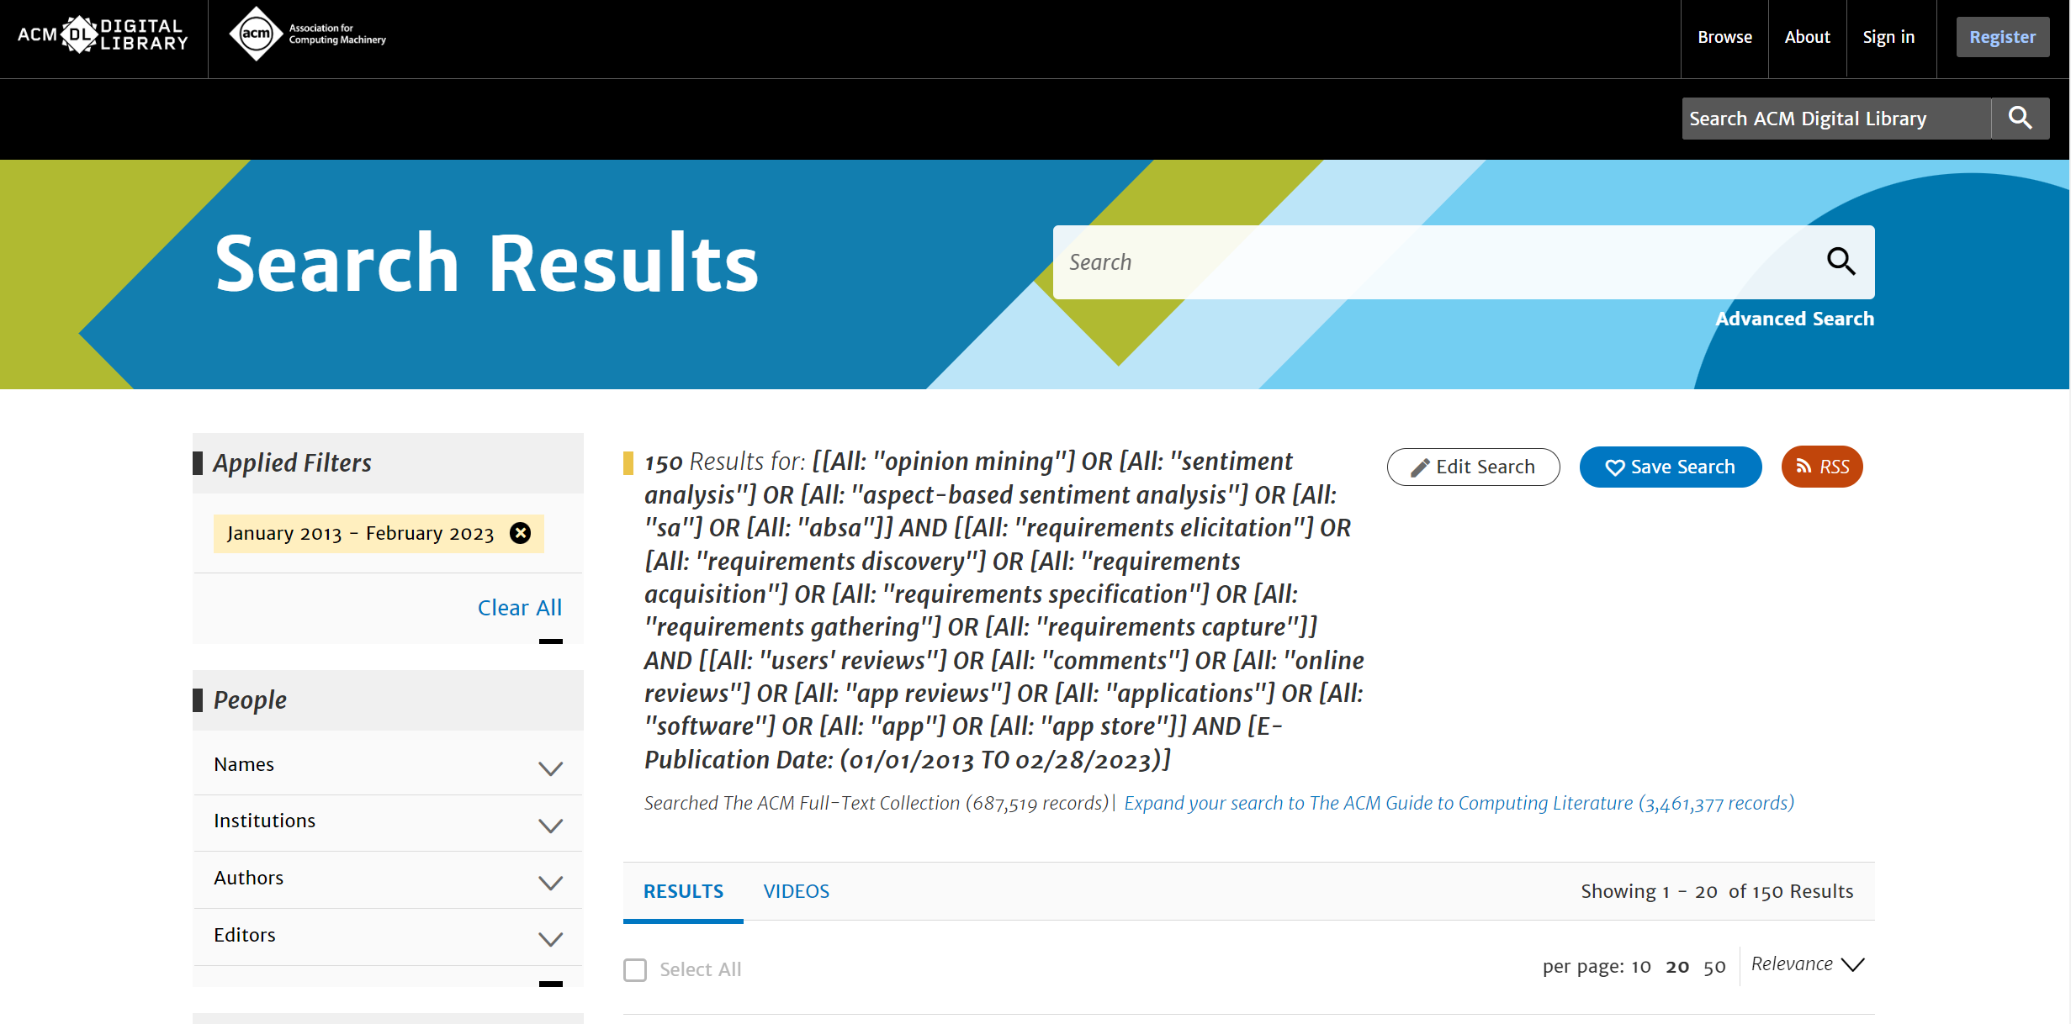

- Elsevier ScienceDirect

https://www.sciencedirect.com/

("opinion mining" OR "sentiment analysis" OR "Aspect-based sentiment analysis" OR "SA" OR "ABSA") AND ("requirements elicitation" OR "requirements discovery" OR "requirements acquisition" OR "requirements specification" OR "requirements gathering" OR "requirements capture") AND ("users' reviews" OR "comments" OR "online reviews" OR "APP reviews" OR "applications" OR "software" OR "app" OR "app store")

Due to the fact that Elsevier ScienceDirect does not allow more than 8 associated words to be retrieved, the search terms are divided into 4 groups and deduplicated
Group1:
("opinion mining" OR "sentiment analysis" OR "Aspect-based sentiment analysis") AND ("requirements elicitation" OR "requirements discovery" OR "requirements acquisition") AND ("comments" OR "online reviews" OR "app store")

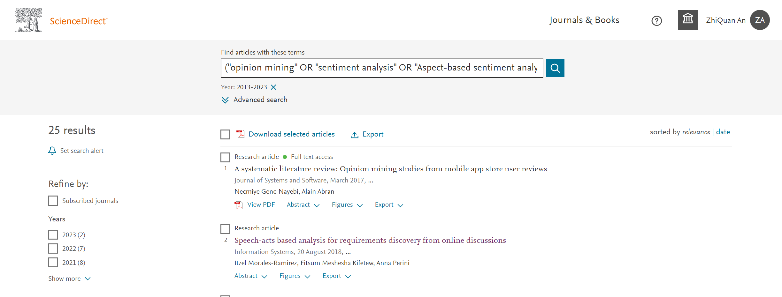

Group2:
("opinion mining" OR "sentiment analysis" ) AND ("requirements elicitation" OR "requirements specification" OR "requirements gathering" OR "requirements capture") AND ("users' reviews" OR "APP reviews" OR "app")

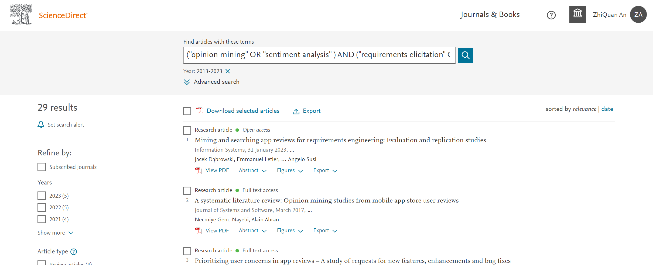

Group3:
("opinion mining" OR "sentiment analysis" OR"ABSA" ) AND ("requirements elicitation" OR "requirements capture") AND ("applications" OR "software" OR "APP reviews" OR"comments" )
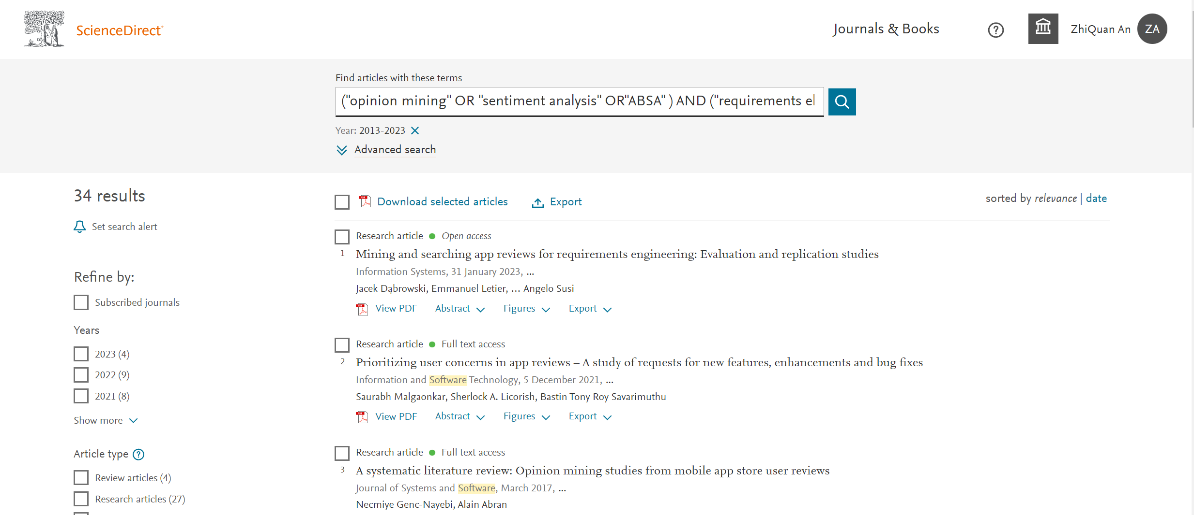
Group4:
("opinion mining" OR "sentiment analysis" OR"SA" ) AND ("requirements elicitation" OR "requirements discovery" OR "requirements acquisition" ) AND ("APP reviews" OR"comments" OR "users' reviews" )

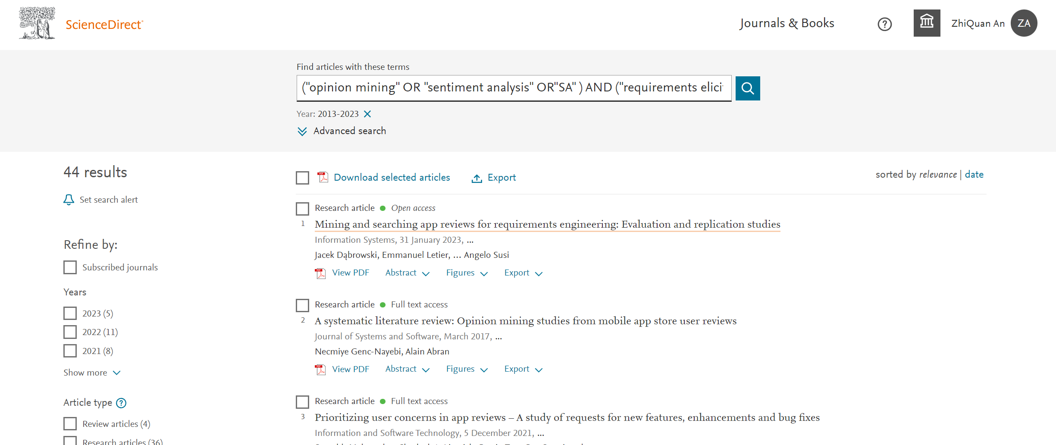

Merge and De-duplication : 63

- EI
https://www.engineeringvillage.com/

("opinion mining" OR "sentiment analysis" OR "Aspect-based sentiment analysis" OR "SA" OR "ABSA") AND ("requirements elicitation" OR "requirements discovery" OR "requirements acquisition" OR "requirements specification" OR "requirements gathering" OR "requirements capture") AND ("users' reviews" OR "comments" OR "online reviews" OR "APP reviews" OR "applications" OR "software" OR "app" OR "app store")

WN KY

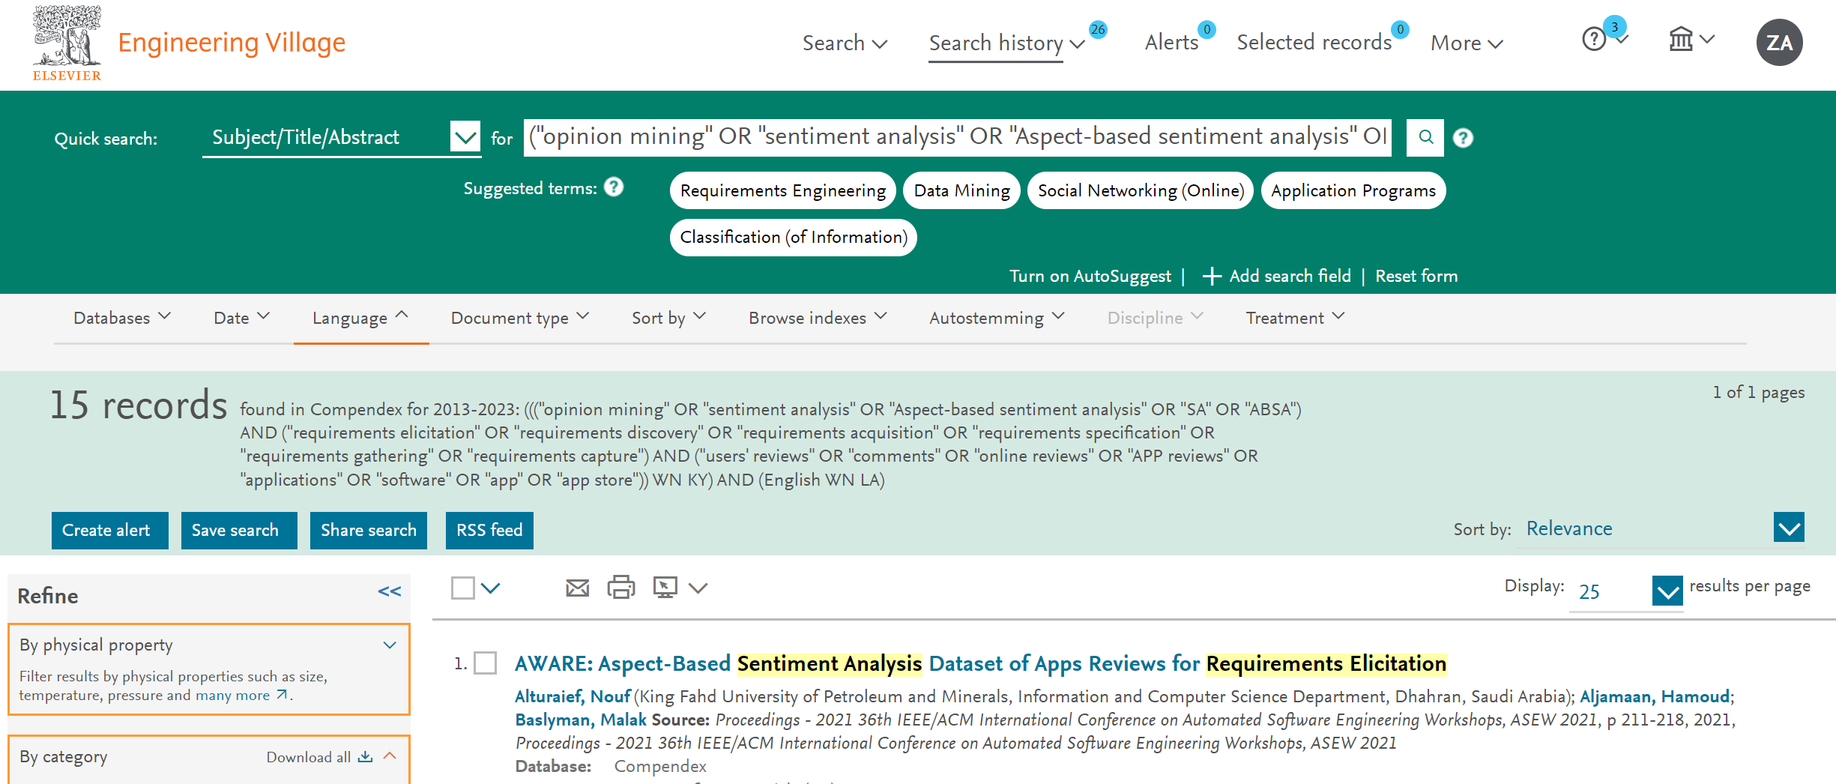

WN ALL
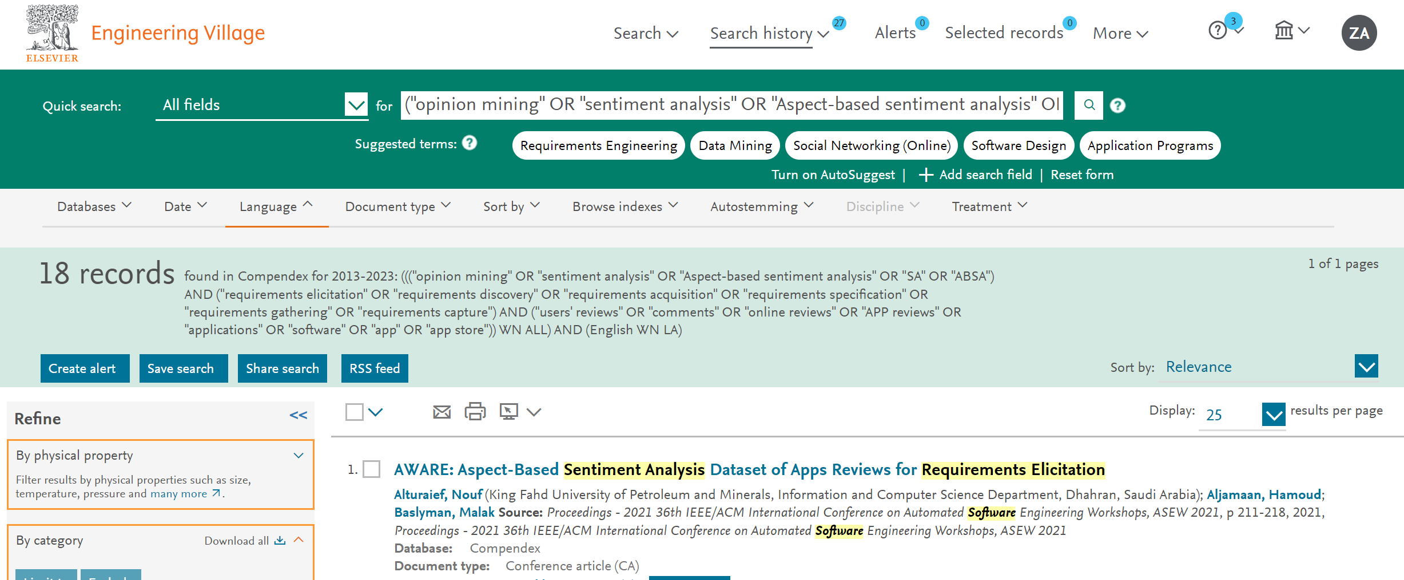

Merge and De-duplication：18

- IEEE
https://ieeexplore.ieee.org/
("All Metadata":"opinion mining" OR "All Metadata":"sentiment analysis" OR "All Metadata":"Aspect-based sentiment analysis" OR "All Metadata":"SA" OR "All Metadata":"ABSA") AND ("All Metadata":"requirements elicitation" OR "All Metadata":"requirements discovery" OR "All Metadata":"requirements acquisition" OR "All Metadata":"requirements specification" OR "All Metadata":"requirements gathering" OR "All Metadata":"requirements capture") AND ("All Metadata":"users' reviews" OR "All Metadata":"comments" OR "All Metadata":"APP reviews" OR "All Metadata":"applications" OR "All Metadata": "software" OR "All Metadata":"app" OR "All Metadata":"app store")

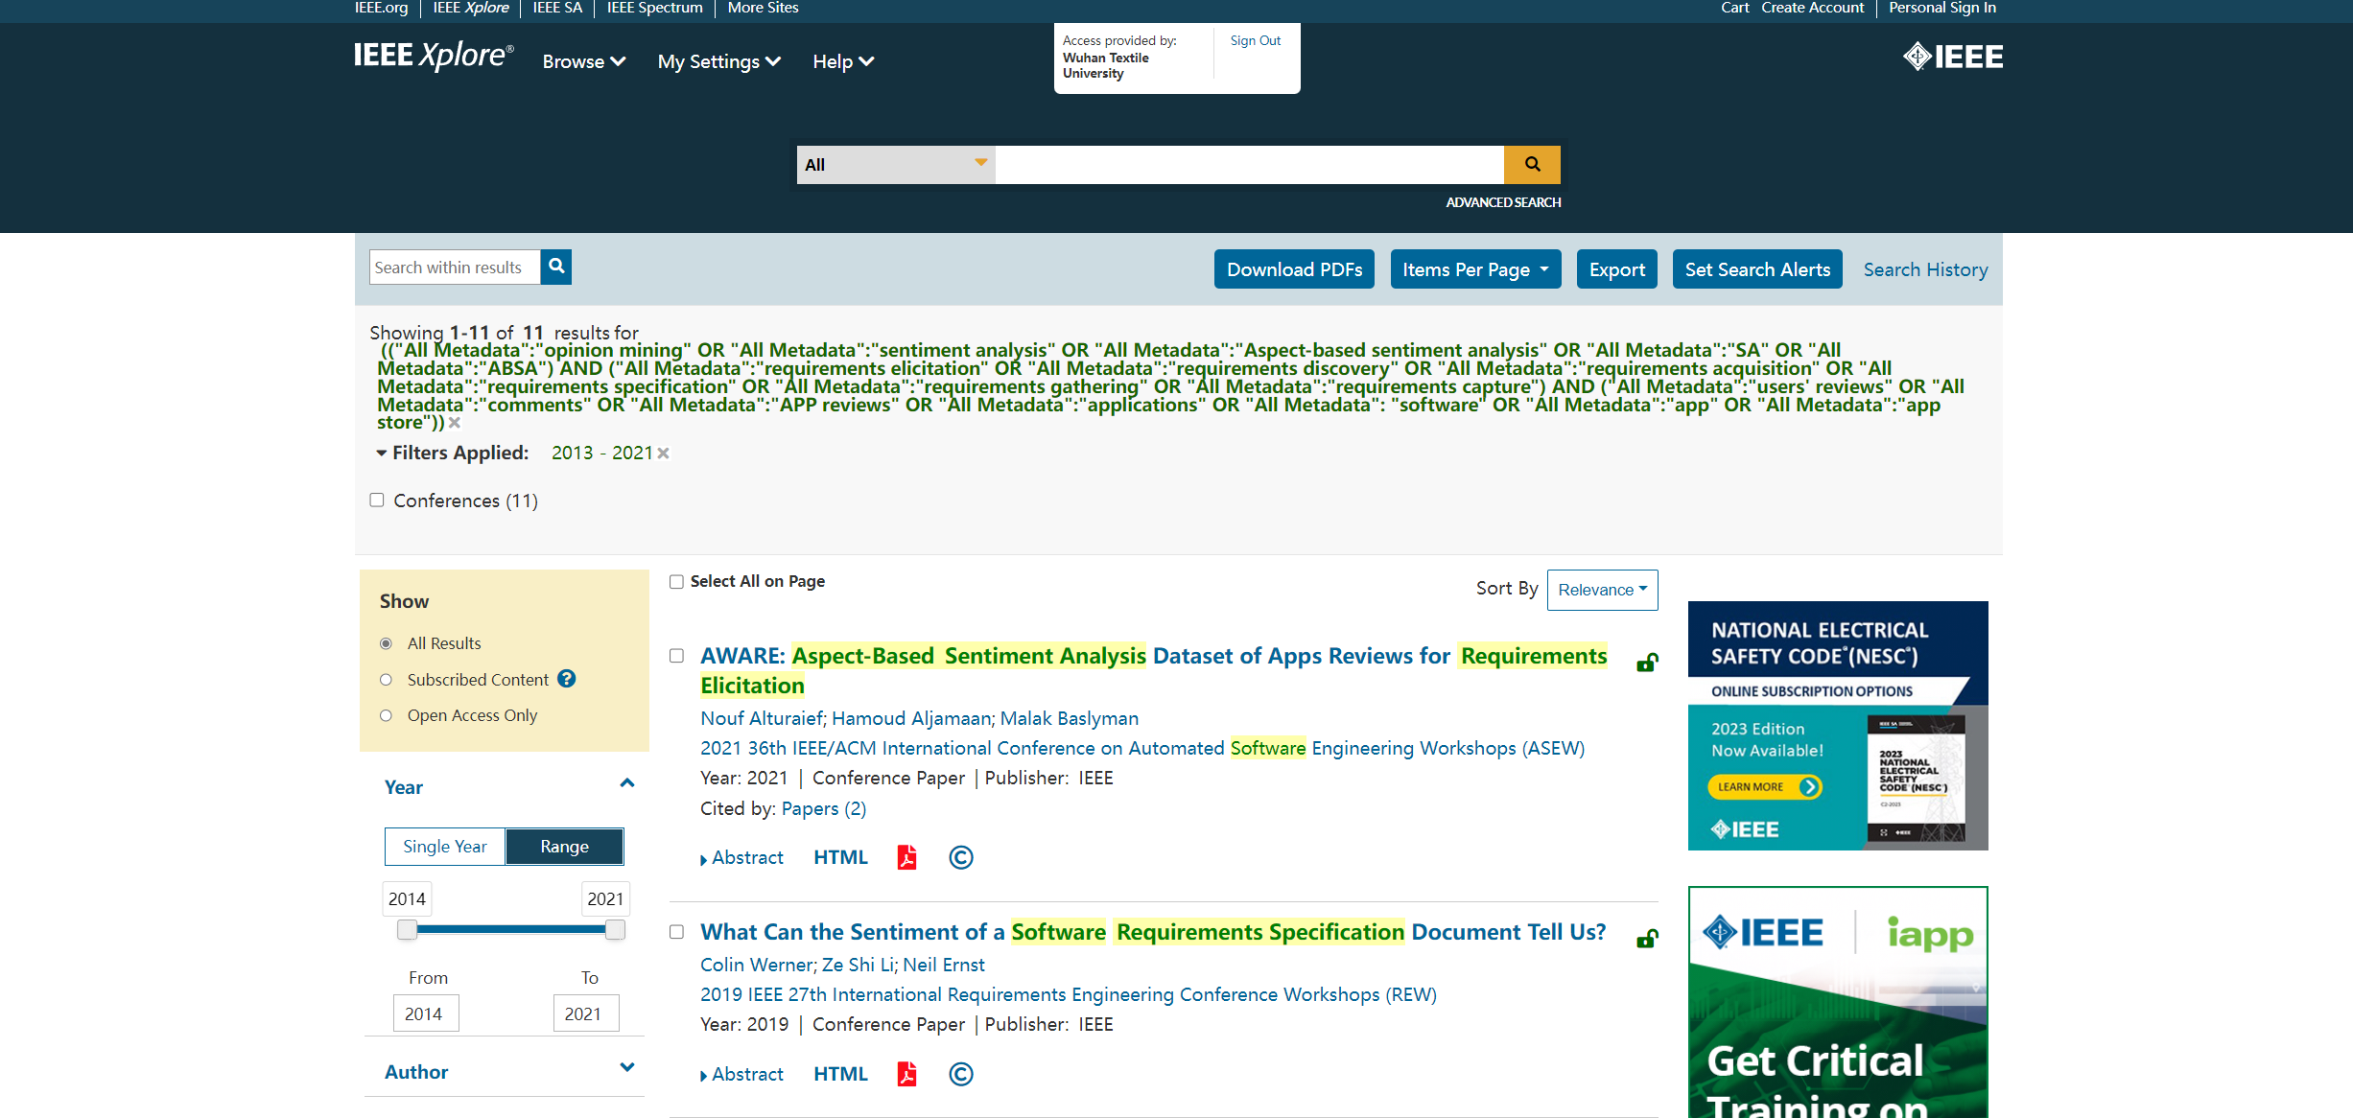
11

- Wiley online library
https://onlinelibrary.wiley.com/

("opinion mining" OR "sentiment analysis") AND ("requirements elicitation" OR "requirements discovery" OR "requirements acquisition" OR "requirements specification" OR "requirements gathering" OR "requirements capture") AND ("users' reviews" OR "comments" OR "online reviews" OR "APP reviews" OR "applications" OR "software") anywhere

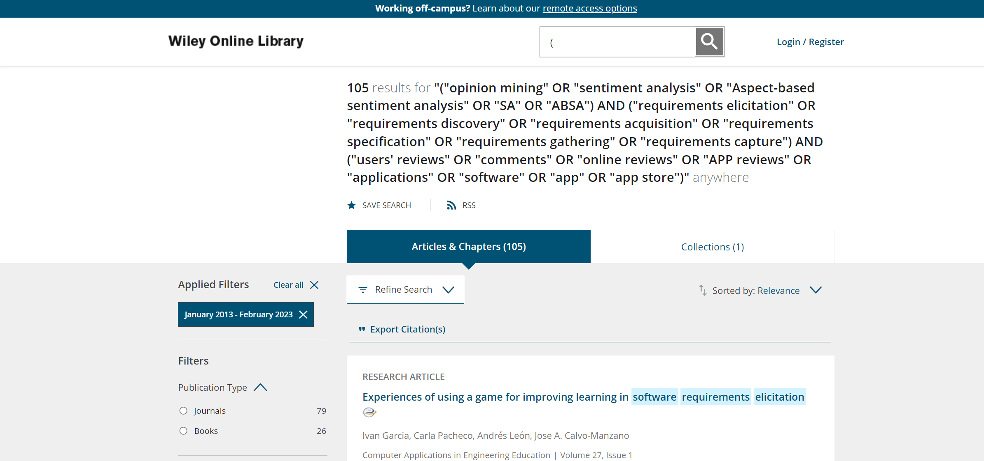
105

1882
A: Exclude duplicates
740
B: Filter by title
conference/journal not secondary & not gray&ex3&in3: 594
C: Filter by abstract
108
D: Content and QA
Include: 29
E: Snowballing：3

How about the quality of these primary studies?
The 33 primary studies are scored for quality according to the criterion (see Fig 1), and the results are shown in Fig 2 and Fig 3. The box plot shows the overall quality score for primary studies and the details of the score distribution in the four dimensions shown by bubble chart.

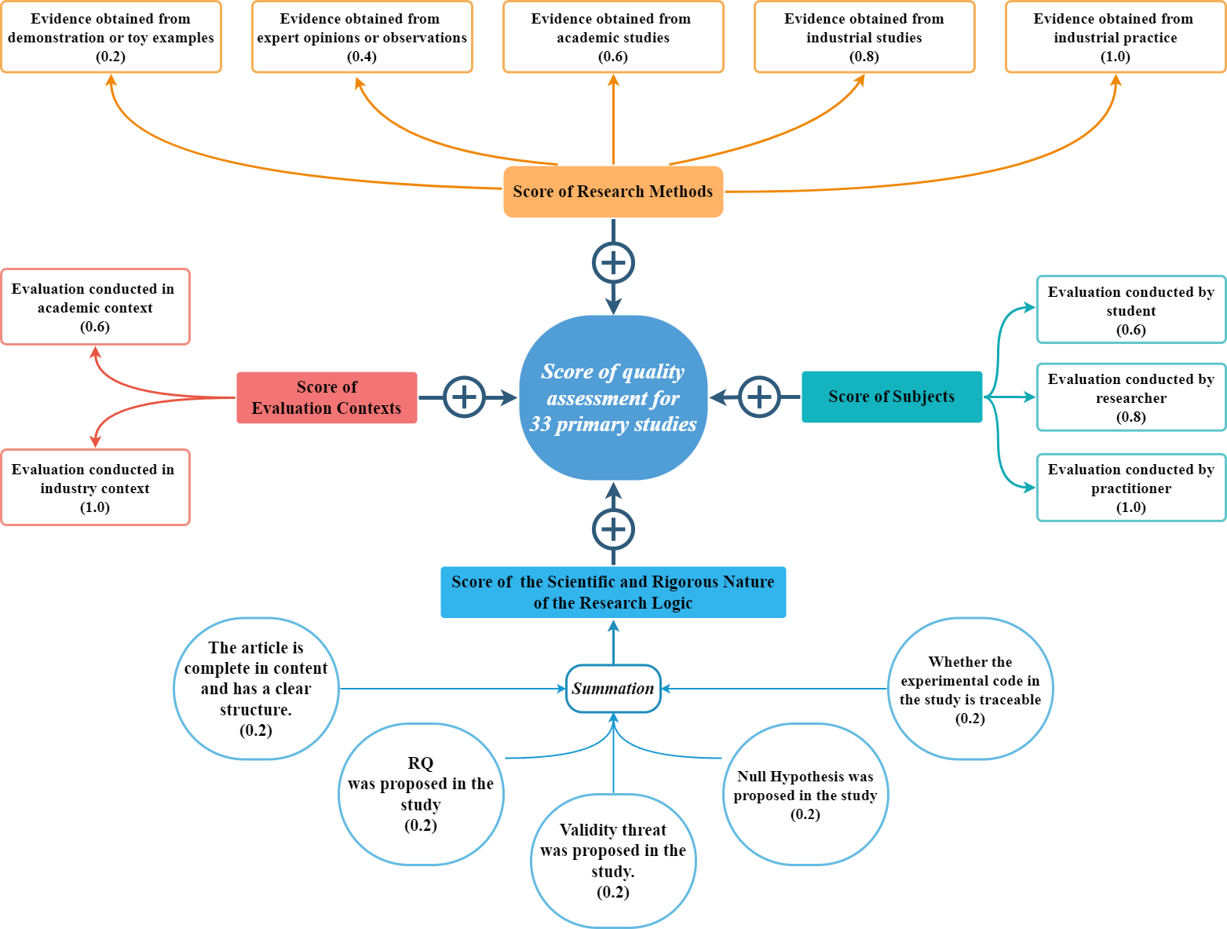
Fig 1. Overall quality score cri criterion
From Fig 2, the median of the primary studies is 2.6, with the mean score is 2.55. Among them, eight papers [S4][S11][S12][S19][S25]-[S28] received the lowest score of 2.0. These low scores can be attributed to factors such as the academic nature of the research, reliance on expert opinions, involvement of student subjects, and incomplete research methodology (e.g., lack of research questions, validity threats, null hypothesis, and source code). On the other hand, the study by Williams [S14] from Microsoft received the highest score of 3.4. Although this study also lacked a null hypothesis and traceable code, it stood out due to its industry context and inclusion of industrial practitioners as subjects.
From Fig 3, almost all studies rely on evidence from academic sources (29/33) and are conducted in an academic context (28/33), such as experiments. Only three industrial practitioners [S14][S17][S32] are in the subject dimension, while the rest are primarily researchers and students. These phenomena imply that the current research in the field lacks relevant industrial practitioner support, practices, and validations (e.g., static and dynamic validation[1][2][3]). In the scientific and rigorous dimension, only one-third of the studies considered four aspects of the evaluation criteria or all of them. The radar chart (see Fig 4) intuitively shows the scores for each aspect. All studies had basic logic, with 50% of the studies asking research questions and discussing threats to the validity of their studies. However, 82% of studies did not propose null hypotheses, and 73% did not publish original data and code to support reproducibility. Future researchers are advised to focus on these aspects to improve the overall quality of the research methodology.
Table 1 demonstrates the overall quality of the included studies. 69.7% of the studies reached the level of good or excellent, indicating an overall superior research status in the field, and the overall quality of the studies included in our work is comparatively high. Therefore, our work is meaningful.

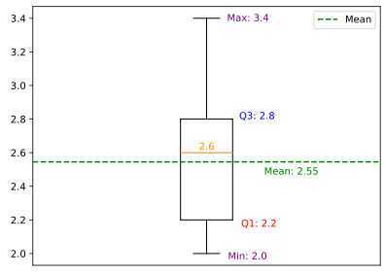
Fig 2. Overall quality score for primary studies

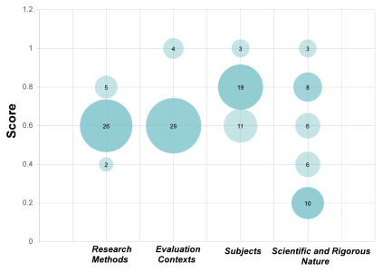
Fig 3. Score distribution in the four dimensions

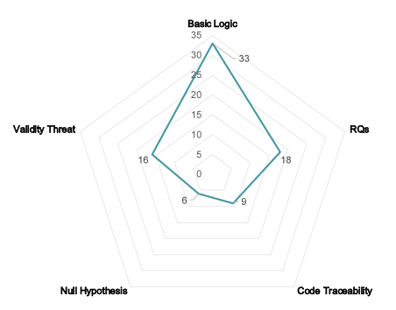
Fig 4. Details of scores for scientific and rigorous research logic
Table 1. The overall quality of the included studies
Level of Quality Score | Number | Percentage | Papers
Poor [0-1.8) | 0 | 0%
Fair [1.8-2.4) | 10 | 30.3% | [S4] [S5] [S11] [S12] [S19] [S24] [S25] [S26] [S27] [S28]
Good [2.4-3) | 17 | 51.6% | [S1] [S6] [S9] [S10] [S13] [S15] [S16] [S18] [S20] [S21] [S22] [S23] [S29] [S30] [S31] [S32] [S33]
Excellent [3-4] | 6 | 18.1% | [S2] [S3] [S7] [S8] [S14] [S17]

Primary studies in the review
- Alturaief, N., Aljamaan, H., Baslyman, M., 2021. AWARE: Aspect-Based Sentiment Analysis Dataset of Apps Reviews for Requirements Elicitation. In: 36th IEEE/ACM International Conference on Automated Software Engineering Workshops (ASEW 2021). Australia, pp. 211–218.
- Araujo, A.F., Gôlo, M.P.S., Marcacini, R.M., 2022. Opinion mining for app reviews: an analysis of textual representation and predictive models. Autom Softw Eng 29, 1–30.
- Bano, M., Zowghi, D., 2015. EVALUATOR: An Automated Tool for Service Selection. In: Liu, L., Aoyama, M. (Eds.), Requirements Engineering in the Big Data Era, Communications in Computer and Information Science. Springer, Berlin, Heidelberg, pp. 170–184.
- Yin, H., Pfahl, D., 2017. A preliminary study on the suitability of stack overflow for open innovation in requirements engineering. In: Proceedings of the 3rd International Conference on Communication and Information Processing (ICCIP ’17). Association for Computing Machinery, Tokyo, Japan, pp. 45–49.
- Al-Shamani, M., Al-Sarem, M., Saeed, F., Almutairi, W., 2022. Designing an Arabic Google Play Store User Review Dataset for Detecting App Requirement Issues. In: Saeed, F., Al-Hadhrami, T., Mohammed, E., Al-Sarem, M. (Eds.), Advances on Smart and Soft Computing, Advances in Intelligent Systems and Computing. Springer, Singapore, pp. 133–143.
- Galvis Carreño, L.V., Winbladh, K., 2013. Analysis of user comments: an approach for software requirements evolution. In: Proceedings of the 2013 International Conference on Software Engineering (ICSE ’13). IEEE Press, San Francisco, CA, USA, pp. 582–591.
- Khan, J.A., Yasin, A., Fatima, R., Vasan, D., Khan, A.A., Khan, A.W., 2022. Valuating requirements arguments in the online user’s forum for requirements decision-making: The CrowdRE-VArg framework. Software: Practice and Experience 52, 2537–2573.
- Henriksson, A., Zdravkovic, J., 2022. Holistic data-driven requirements elicitation in the big data era. Softw Syst Model 21, 1389–1410.
- Malgaonkar, S., Licorish, S.A., Savarimuthu, B.T.R., 2022. Prioritizing user concerns in app reviews – A study of requests for new features, enhancements and bug fixes. Information and Software Technology 144, 106798.
- Gao, H., Guo, C., Bai, G., Huang, D., He, Z., Wu, Y., Xu, J., 2022. Sharing runtime permission issues for developers based on similar-app review mining. Journal of Systems and Software 184, 111118.
- Gunathilaka, S., De Silva, N., 2022. Aspect-based Sentiment Analysis on Mobile Application Reviews. In: 22nd International Conference on Advances in ICT for Emerging Regions (ICTer 2022). Sri lanka, pp. 183–188.
- Zhao, H., Liu, Z., Lyu, J., 2020. Implicit Knowledge-Oriented New Product Development Based on Online Review. In: Deepak, BBVL., Parhi, D., Jena, P.C. (Eds.), Innovative Product Design and Intelligent Manufacturing Systems, Lecture Notes in Mechanical Engineering. Springer, Singapore, pp. 839–846.
- Novielli, N., Calefato, F., Dongiovanni, D., Girardi, D., Lanubile, F., 2020. Can We Use SE-specific Sentiment Analysis Tools in a Cross-Platform Setting? In: Proceedings of the 17th International Conference on Mining Software Repositories (MSR ’20). New York, NY, USA, pp. 158–168.
- Williams, G., Tushev, M., Ebrahimi, F., Mahmoud, A., 2020. Modeling user concerns in Sharing Economy: the case of food delivery apps. Autom Softw Eng 27, 229–263.
- Oehri, E., Guzman, E., 2020. Same Same but Different: Finding Similar User Feedback Across Multiple Platforms and Languages. In: 2020 IEEE 28th International Requirements Engineering Conference (RE). Zurich, Switzerland, pp. 44–54.
- Morales-Ramirez, I., Kifetew, F.M., Perini, A., 2019. Speech-acts based analysis for requirements discovery from online discussions. Information Systems 86, 94–112.
- Jha, N., Mahmoud, A., 2019. Mining non-functional requirements from App store reviews. Empir Software Eng 24, 3659–3695.
- Guzman, E., Alkadhi, R., Seyff, N., 2017. An exploratory study of Twitter messages about software applications. Requirements Eng 22, 387–412.
- Jiang, W., Ruan, H., Zhang, L., Lew, P., Jiang, J., 2014. For User-Driven Software Evolution: Requirements Elicitation Derived from Mining Online Reviews. In: Tseng, V.S., Ho, T.B., Zhou, Z.-H., Chen, A.L.P., Kao, H.-Y. (Eds.), Advances in Knowledge Discovery and Data Mining, Lecture Notes in Computer Science. Springer International Publishing, Cham, pp. 584–595.
- Morales-Ramirez, I., Kifetew, F.M., Perini, A., 2017. Analysis of Online Discussions in Support of Requirements Discovery. In: Dubois, E., Pohl, K. (Eds.), Advanced Information Systems Engineering, Lecture Notes in Computer Science. Springer International Publishing, Cham, pp. 159–174.
- Nguyen, V., Svee, E.-O., Zdravkovic, J., 2016. A Semi-automated Method for Capturing Consumer Preferences for System Requirements. In: Horkoff, J., Jeusfeld, M.A., Persson, A. (Eds.), The Practice of Enterprise Modeling, Lecture Notes in Business Information Processing. Springer International Publishing, Cham, pp. 117–132.
- Calefato, F., Lanubile, F., Maiorano, F., Novielli, N., 2018. Sentiment Polarity Detection for Software Development. Empir Software Eng 23, 1352–1382.
- Gu, X., Kim, S., 2015. “ what parts of your apps are loved by users?”(T). In: 2015 30th IEEE/ACM International Conference on Automated Software Engineering (ASE). IEEE, Lincoln, NE, USA, pp. 760–770.
- Atoum, I., 2020. A novel framework for measuring software quality-in-use based on semantic similarity and sentiment analysis of software reviews. Journal of King Saud University - Computer and Information Sciences 32, 113–125.
- Su, Y., Wang, Y., Yang, W., 2019. Mining and Comparing User Reviews across Similar Mobile Apps. In: 2019 15th International Conference on Mobile Ad-Hoc and Sensor Networks (MSN). Shenzhen, China, pp. 338–342.
- Zhao, L., Zhao, A., 2019. Sentiment Analysis Based Requirement Evolution Prediction. Future Internet 11, 52.
- Yin, H., Pfahl, D., 2018. The OIRE Method - Overview and Initial Validation. In: 2018 25th Asia-Pacific Software Engineering Conference (APSEC). Nara, Japan, pp. 1–10.
- Luiz, W., Viegas, F., Alencar, R., Mourão, F., Salles, T., Carvalho, D., Gonçalves, M.A., Rocha, L., 2018. A Feature-Oriented Sentiment Rating for Mobile App Reviews. In: Proceedings of the 2018 World Wide Web Conference on World Wide Web (WWW ’18). Lyon, France, pp. 1909–1918.
- Guzman, E., Maalej, W., 2014. How Do Users Like This Feature? A Fine Grained Sentiment Analysis of App Reviews. In: 2014 IEEE 22nd International Requirements Engineering Conference (RE). Lincoln, NE, USA, pp. 153–162.
- Panichella, S., Di Sorbo, A., Guzman, E., Visaggio, C.A., Canfora, G., Gall, H.C., 2015. How can I improve my app? Classifying user reviews for software maintenance and evolution. In: 2015 IEEE International Conference on Software Maintenance and Evolution (ICSME). Bremen, Germany, pp. 281–290.
- Maalej, W., Nabil, H., 2015. Bug report, feature request, or simply praise? On automatically classifying app reviews. In: 2015 IEEE 23rd International Requirements Engineering Conference (RE). Ottawa, ON, Canada, pp. 116–125.
- Fu, B., Lin, J., Li, L., Faloutsos, C., Hong, J., Sadeh, N., 2013. Why people hate your app: making sense of user feedback in a mobile app store. In: Proceedings of the 19th ACM SIGKDD International Conference on Knowledge Discovery and Data Mining. Chicago Illinois USA, pp. 1276–1284.
- Al-Hawari, A., Najadat, H., Shatnawi, R., 2021. Classification of application reviews into software maintenance tasks using data mining techniques. Software Quality Journal 29, 667–703.
Reference
- Alves, V., Niu, N., Alves, C., Valença, G., 2010. Requirements engineering for software product lines: A systematic literature review. Information and Software Technology 52, 806–820.
- Dybå, T., Dingsøyr, T., 2008. Strength of evidence in systematic reviews in software engineering. In: Proceedings of the Second ACM-IEEE International Symposium on Empirical Software Engineering and Measurement. Presented at the ESEM ’08: 2008 ACM-IEEE International Symposium on Empirical Software Engineering and Measurement, ACM, Kaiserslautern Germany, pp. 178–187.
- Ivarsson, M., Gorschek, T., 2009. Technology transfer decision support in requirements engineering research: a systematic review of REj. Requirements Eng 14, 155–175.

